Lab 4 — Using Factories

Complete Step-by-Step Procedure with Commands

Create Lab 4 from Lab 3
Go to the UVM directory:
cd /mnt/hgfs/uvm
Create the directory:
mkdir -p lab04_factory
Copy Lab 3 contents:
cp -R lab03_uvc/* lab04_factory/
Check:
cd lab04_factory
ls

router_test_lib.sv
make a backup:
cp router_test_lib.sv router_test_lib.sv.bak
nano router_test_lib.sv

class base_test extends uvm_test;

`uvm_component_utils(base_test)

router_tb tb;

function new(string name = "base_test", uvm_component parent = null);
super.new(name, parent);
endfunction

virtual function void build_phase(uvm_phase phase);
super.build_phase(phase);

uvm_config_int::set(this, "*", "recording_detail", 1);

tb = router_tb::type_id::create("tb", this);

`uvm_info("BASE_TEST",
"Build phase of the test is being executed",
UVM_HIGH)
endfunction

virtual function void check_phase(uvm_phase phase);
super.check_phase(phase);
check_config_usage();
endfunction

virtual function void end_of_elaboration_phase(uvm_phase phase);
uvm_top.print_topology();
endfunction

endclass
Save:

router_tb.sv
nano router_tb.sv
Use:
class router_tb extends uvm_env;

`uvm_component_utils(router_tb)

function new(string name = "router_tb", uvm_component parent = null);
super.new(name, parent);
endfunction

virtual function void build_phase(uvm_phase phase);
super.build_phase(phase);

`uvm_info("ROUTER_TB",
"Build phase of the testbench is being executed",
UVM_HIGH)
endfunction

endclass

yapp_env.sv
Go to sv:
cd ../sv
Open:
nano yapp_env.sv

class yapp_env extends uvm_env;

`uvm_component_utils(yapp_env)

yapp_tx_agent agent;

function new(string name = "yapp_env", uvm_component parent = null);
super.new(name, parent);
endfunction

virtual function void build_phase(uvm_phase phase);
super.build_phase(phase);

agent = yapp_tx_agent::type_id::create("agent", this);
endfunction

endclass

yapp_tx_agent.sv
Open:
nano yapp_tx_agent.sv
The structure should be:
class yapp_tx_agent extends uvm_agent;

`uvm_component_utils_begin(yapp_tx_agent)
`uvm_field_enum(uvm_active_passive_enum, is_active, UVM_ALL_ON)
`uvm_component_utils_end

yapp_tx_monitor monitor;
yapp_tx_driver driver;
yapp_tx_sequencer sequencer;

function new(string name = "yapp_tx_agent",
uvm_component parent = null);
super.new(name, parent);
endfunction

virtual function void build_phase(uvm_phase phase);
super.build_phase(phase);

monitor = yapp_tx_monitor::type_id::create("monitor", this);

if (is_active == UVM_ACTIVE) begin
driver = yapp_tx_driver::type_id::create("driver", this);
sequencer = yapp_tx_sequencer::type_id::create("sequencer", this);
end
endfunction

virtual function void connect_phase(uvm_phase phase);
super.connect_phase(phase);

if (is_active == UVM_ACTIVE) begin
driver.seq_item_port.connect(sequencer.seq_item_export);
end
endfunction

endclass

Factory changes
Driver:
driver = yapp_tx_driver::type_id::create("driver", this);
Sequencer:
sequencer = yapp_tx_sequencer::type_id::create("sequencer", this);
Monitor:
monitor = yapp_tx_monitor::type_id::create("monitor", this);

Add short_yapp_packet
Open:
nano yapp_packet.sv
end of the file and add:
class short_yapp_packet extends yapp_packet;

`uvm_object_utils(short_yapp_packet)

function new(string name = "short_yapp_packet");
super.new(name);
endfunction

constraint short_length {
length < 15;
}

constraint no_address_2 {
addr != 2;
}

endclass : short_yapp_packet

Add short_packet_test
Go to tb:
cd ../tb
Open:
nano router_test_lib.sv
After base_test, add:
class short_packet_test extends base_test;

`uvm_component_utils(short_packet_test)

function new(string name = "short_packet_test",
uvm_component parent = null);
super.new(name, parent);
endfunction

virtual function void build_phase(uvm_phase phase);

yapp_packet::type_id::set_type_override(
short_yapp_packet::get_type()
);

super.build_phase(phase);

endfunction

endclass : short_packet_test
Use this corrected version.

Compile and run base_test
xrun -f run.f +UVM_TESTNAME=base_test +SVSEED=random

Run short_packet_test
xrun -f run.f +UVM_TESTNAME=short_packet_test +SVSEED=random

Create set_config_test
Open:
nano router_test_lib.sv
Add this after short_packet_test:
class set_config_test extends base_test;

`uvm_component_utils(set_config_test)

function new(string name = "set_config_test",
uvm_component parent = null);
super.new(name, parent);
endfunction

virtual function void build_phase(uvm_phase phase);

uvm_config_int::set(
this,
"tb.yapp.agent",
"is_active",
UVM_PASSIVE
);

super.build_phase(phase);

endfunction

endclass : set_config_test

Run set_config_test
Run:
xrun -f run.f +UVM_TESTNAME=set_config_test

Test all three tests

Test 1 — Normal factory test
xrun -f run.f +UVM_TESTNAME=base_test

Test 2 — Short packet factory override
xrun -f run.f +UVM_TESTNAME=short_packet_test

Test 3 — Configuration test
xrun -f run.f +UVM_TESTNAME=set_config_test

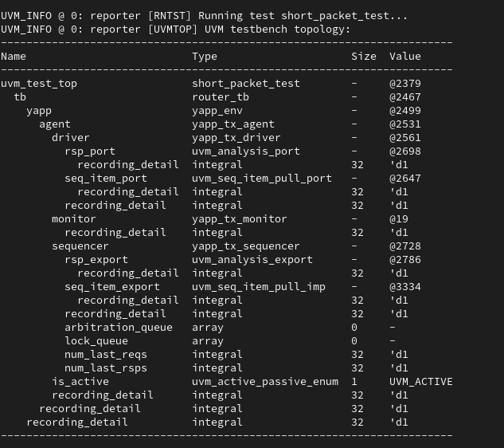
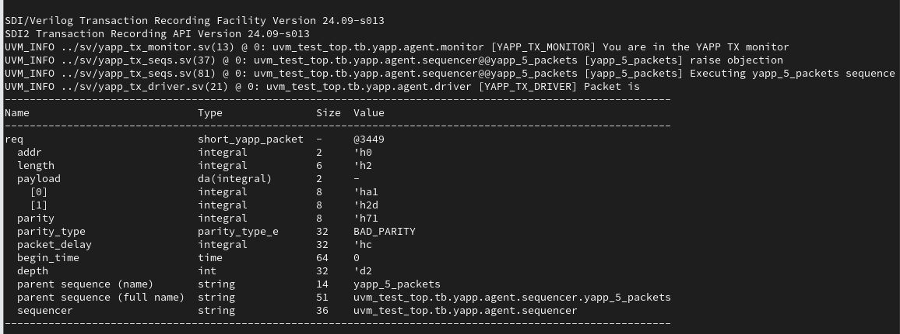
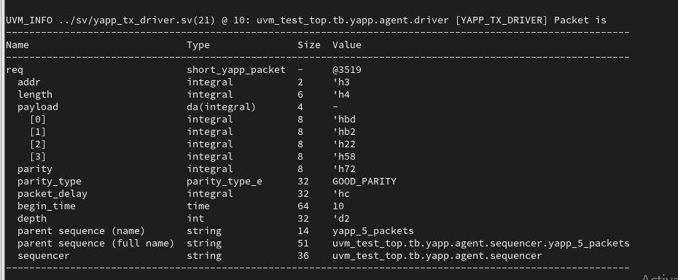
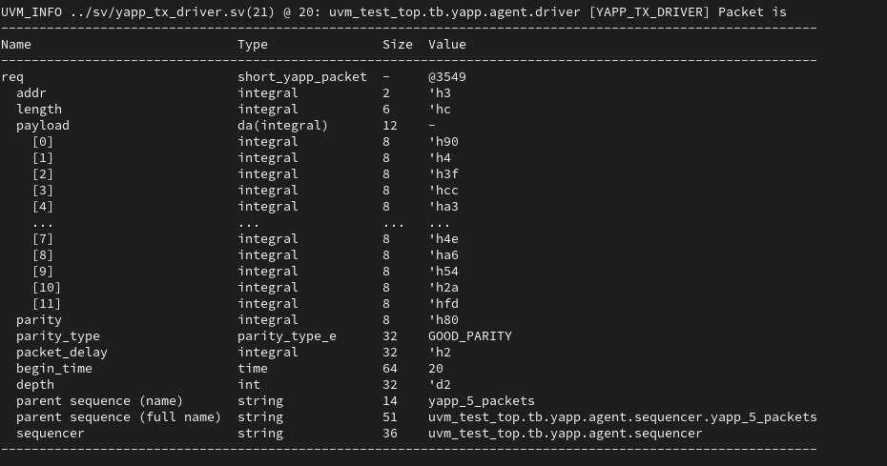
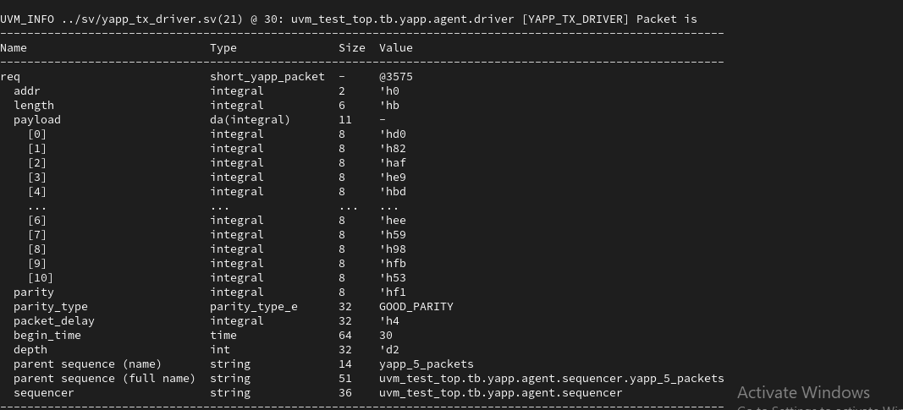
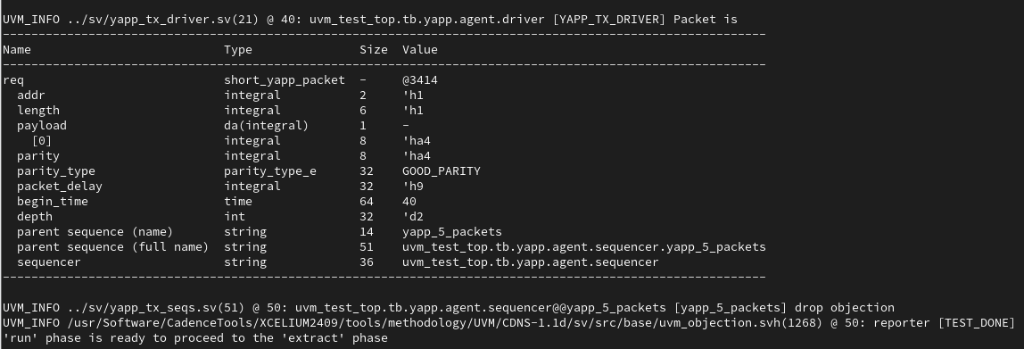
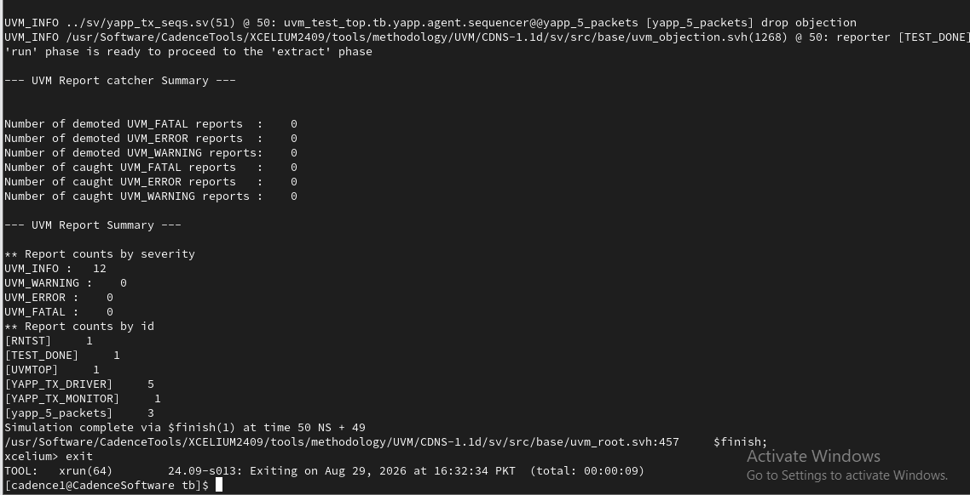
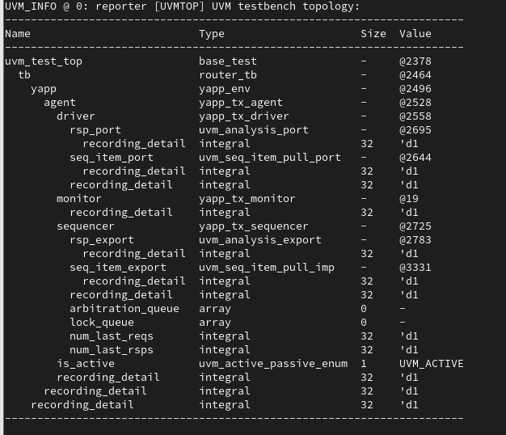

[cadence1@CadenceSoftware tb]$ xrun -f run.f +UVM_TESTNAME=set_config_test
TOOL: xrun(64) 24.09-s013: Started on Aug 29, 2026 at 16:58:06 PKT
xrun(64): 24.09-s013: (c) Copyright 1995-2025 Cadence Design Systems, Inc.
Recompiling... reason: file './router_test_lib.sv' is newer than expected.
expected: Sat Aug 29 16:31:23 2026
actual: Sat Aug 29 16:56:50 2026
Compiling UVM packages (uvm_pkg.sv cdns_uvm_pkg.sv) using uvmhome location /usr/Software/CadenceTools//XCELIUM2409/tools/methodology/UVM/CDNS-1.1d
file: ../sv/yapp_pkg.sv
package yapp_pkg;
|
xmvlog: *W,TSNSPK (../sv/yapp_pkg.sv,1|15): `timescale is not specified for the package. The default timescale of 1ns/1ns will be assumed for this package.
file: top.sv
module worklib.top:sv
errors: 0, warnings: 0
Caching library 'worklib' ....... Done
Elaborating the design hierarchy:
Top level design units:
uvm_pkg
cdns_uvmapi
cdns_assert2uvm_pkg
cdns_uvm_pkg
yapp_pkg
top
Building instance overlay tables: .................... Done
Generating native compiled code:
worklib.top:sv <0x2cd72f30>
streams: 84, words: 57572
worklib.yapp_pkg:sv <0x2cb9df2f>
streams: 466, words: 517447
Building instance specific data structures.
Loading native compiled code: .................... Done
Design hierarchy summary:
Instances Unique
Modules: 1 1
Verilog packages: 5 5
Registers: 13,785 10,238
Named events: 4 12
Initial blocks: 292 158
Parallel blocks: 26 27
Assertions: 2 2
SV Class declarations: 202 316
SV Class specializations: 384 384
Writing initial simulation snapshot: worklib.top:sv
In file included from ./xcelium.d/worklib/top/sv/_sv_export.c:7:
/usr/Software/CadenceTools/XCELIUM2409/tools.lnx86/cdsgcc/gcc/9.3/install/include/c++/9.3.0/stdlib.h:30:16: fatal error: stdlib.h: No such file or directory
30 | # include_next <stdlib.h>
| ^~~~~~~~~~
compilation terminated.
xmelab: *W,DPIEXP: DPI export function in _sv_export.so not available.
In file included from ./xcelium.d/worklib/top/sv/_sv_export.c:7:
/usr/Software/CadenceTools/XCELIUM2409/tools.lnx86/cdsgcc/gcc/9.3/install/include/c++/9.3.0/stdlib.h:30:16: fatal error: stdlib.h: No such file or directory
30 | # include_next <stdlib.h>
| ^~~~~~~~~~
compilation terminated.
xmelab: *W,DPIEXP: DPI export function in _sv_export.so not available.
In file included from ./xcelium.d/worklib/top/sv/_sv_export.c:7:
/usr/Software/CadenceTools/XCELIUM2409/tools.lnx86/cdsgcc/gcc/9.3/install/include/c++/9.3.0/stdlib.h:30:16: fatal error: stdlib.h: No such file or directory
30 | # include_next <stdlib.h>
| ^~~~~~~~~~
compilation terminated.
xmelab: *W,DPIEXP: DPI export function in _sv_export.so not available.
Loading snapshot worklib.top:sv .................... Done
SVSEED default: 1
xmsim: *E,IMPDLL: Unable to load the implicit shared object.
OSDLERROR: (null)/top/sv/_sv_export.so: cannot open shared object file: No such file or directory or file is not valid ELFCLASS64 library..
xcelium> source /usr/Software/CadenceTools/XCELIUM2409/tools/xcelium/files/xmsimrc
xcelium> source /usr/Software/CadenceTools//XCELIUM2409/tools/methodology/UVM/CDNS-1.1d/additions/sv/files/tcl/uvm_sim.tcl
xcelium> run
----------------------------------------------------------------
CDNS-UVM-1.1d (24.09-s013)
(C) 2007-2013 Mentor Graphics Corporation
(C) 2007-2013 Cadence Design Systems, Inc.
(C) 2006-2013 Synopsys, Inc.
(C) 2011-2013 Cypress Semiconductor Corp.
----------------------------------------------------------------

*********** IMPORTANT RELEASE NOTES ************

You are using a version of the UVM library that has been compiled
with `UVM_NO_DEPRECATED undefined.
See http://www.eda.org/svdb/view.php?id=3313 for more details.

You are using a version of the UVM library that has been compiled
with `UVM_OBJECT_MUST_HAVE_CONSTRUCTOR undefined.
See http://www.eda.org/svdb/view.php?id=3770 for more details.

(Specify +UVM_NO_RELNOTES to turn off this notice)

UVM_INFO @ 0: reporter [RNTST] Running test set_config_test...
UVM_INFO @ 0: reporter [UVMTOP] UVM testbench topology:
----------------------------------------------------------------------
Name Type Size Value
----------------------------------------------------------------------
uvm_test_top set_config_test - @2381
tb router_tb - @2463
yapp yapp_env - @2495
agent yapp_tx_agent - @2527
monitor yapp_tx_monitor - @2560
recording_detail integral 32 'd1
is_active uvm_active_passive_enum 1 UVM_PASSIVE
recording_detail integral 32 'd1
recording_detail integral 32 'd1
recording_detail integral 32 'd1
----------------------------------------------------------------------

UVM_INFO ../sv/yapp_tx_monitor.sv(13) @ 0: uvm_test_top.tb.yapp.agent.monitor [YAPP_TX_MONITOR] You are in the YAPP TX monitor

--- UVM Report catcher Summary ---

Number of demoted UVM_FATAL reports : 0
Number of demoted UVM_ERROR reports : 0
Number of demoted UVM_WARNING reports: 0
Number of caught UVM_FATAL reports : 0
Number of caught UVM_ERROR reports : 0
Number of caught UVM_WARNING reports : 0

--- UVM Report Summary ---

** Report counts by severity
UVM_INFO : 3
UVM_WARNING : 0
UVM_ERROR : 0
UVM_FATAL : 0
** Report counts by id
[RNTST] 1
[UVMTOP] 1
[YAPP_TX_MONITOR] 1
Simulation complete via $finish(1) at time 0 FS + 179
/usr/Software/CadenceTools/XCELIUM2409/tools/methodology/UVM/CDNS-1.1d/sv/src/base/uvm_root.svh:457 $finish;
xcelium> exit
TOOL: xrun(64) 24.09-s013: Exiting on Aug 29, 2026 at 16:58:12 PKT (total: 00:00:06)
[cadence1@CadenceSoftware tb]$

